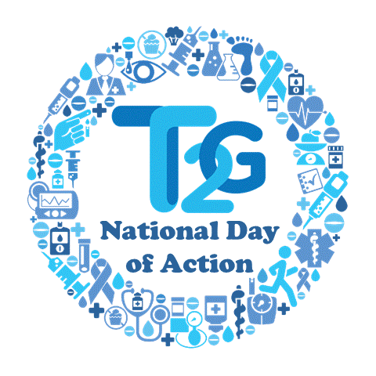
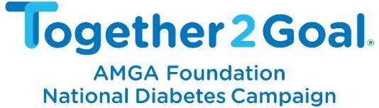

T2G Talk & Taste
Staff Invitation Template

Customize the below T2G Talk & Taste staff invitation template to communicate the details of the event to your diabetes team. The content can be modified for an email, Outlook Calendar invitation, posting on your internal portal, or even a team newsletter. Depending on the channel you use, consider asking for RSVPs from staff so you can get an accurate headcount for food.

From: [T2G Talk & Taste Leader]
To: [Diabetes Team members]

Subject: Discuss diabetes care over [meal] on [Thurs., 11/8]!

Hello -

As you may know, [organization name] is one of 150 medical groups and health systems participating in AMGA’s Together 2 Goal® (T2G) campaign. This national campaign aims to collectively improve care for 1 million people living with Type 2 diabetes by 2019.

T2G will hold its annual observance—National Day of Action—on November 8. On this day, health professionals across the country will come together to “take action” to improve diabetes care.

On [date], we are “taking action” by watching a two-minute T2G provider video over a healthy [breakfast, lunch, snack] and discussing its application in treating our patients with diabetes.

Here are the details:

[Date, time]
Who: [Organization]’s diabetes team
What: T2G Talk & Taste—talking diabetes care over a healthy [breakfast, lunch, snack]
Where: [Location]
Why: To “take action” and discuss how we can improve diabetes care for our patients

We hope you will join us!
[Name of T2G Talk & Taste Leader]

